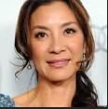
The Lady, directed by Luc Besson

Aung San Suu Kyi Michelle Yeoh

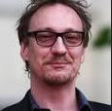
Michael Aris David Thewlis

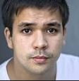
Alexander Aris Jonothan Woodhouse

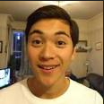
Kim Aris Jonathan Raggett

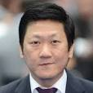
Karma Phuntsho Benedict Wong

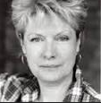
Lucinda Philips Susan Wooldridge

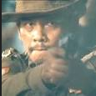
Captain Myint Maung Maung Khin

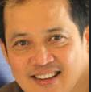
Leo Nichols Sahajak Boonthanakit

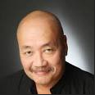
Burmese Diplomat Junix Inocian

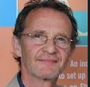
Professor Finnis Anton Lesser

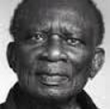
Desmond Tutu Ilario Bisi-Pedro

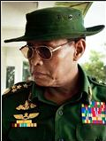
General Ne Win Htun Lin

